Anneka Lenssen

240 words

**Nseir, Leila (Born Lattakia, Syria, 1941)**

Leila Nseir was one of the first women artists in Syria to achieve recognition in the organisational structures of the national art movement. In 1961 she traveled to Cairo to study oil painting at the Faculty of Fine Arts alongside other Syrian, Egyptian, and Arab students. The Cairo plan of academic study, which emphasised technical skill as well as observation of social and labour realities, gave key definition to the artistic values of her generation of politically aware artists. Upon returning to Cairo, Nseir worked as an art educator while also regularly exhibiting in the national exhibitions. In the 1960s, her paintings often explored the themes of oppression and imperialist aggression. She was active in the Syndicate of Fine Artists in the 1970s, contributing to conferences and pan-Arab art exhibitions, and participating in sketching tours at refugee camps and fedayeen training programs. She also began to develop a post-Cubistic style of simplified ink drawing. In later decades, Nseir focused most intently on representations of the female subject. Often working with acrylic colors and resist techniques, she painted arrays of stacked figures that show signs of emotional and physical distress.

**References and further reading**

Atassi, Mouna, and Samir Sayegh (1998) *Contemporary Art in Syria, 1898-1998*, Damascus, Syria: Gallery Atassi. (Contributor’s comment: Most comprehensively illustrated volume on modern Syrian art).

Ayyam Gallery (2008) *Leila Nseir,* Damascus: Ayyam Gallery. (Contributor’s comment: 155-page catalog from artist’s solo exhibition at a private gallery in Damascus).

**Paratextual material**

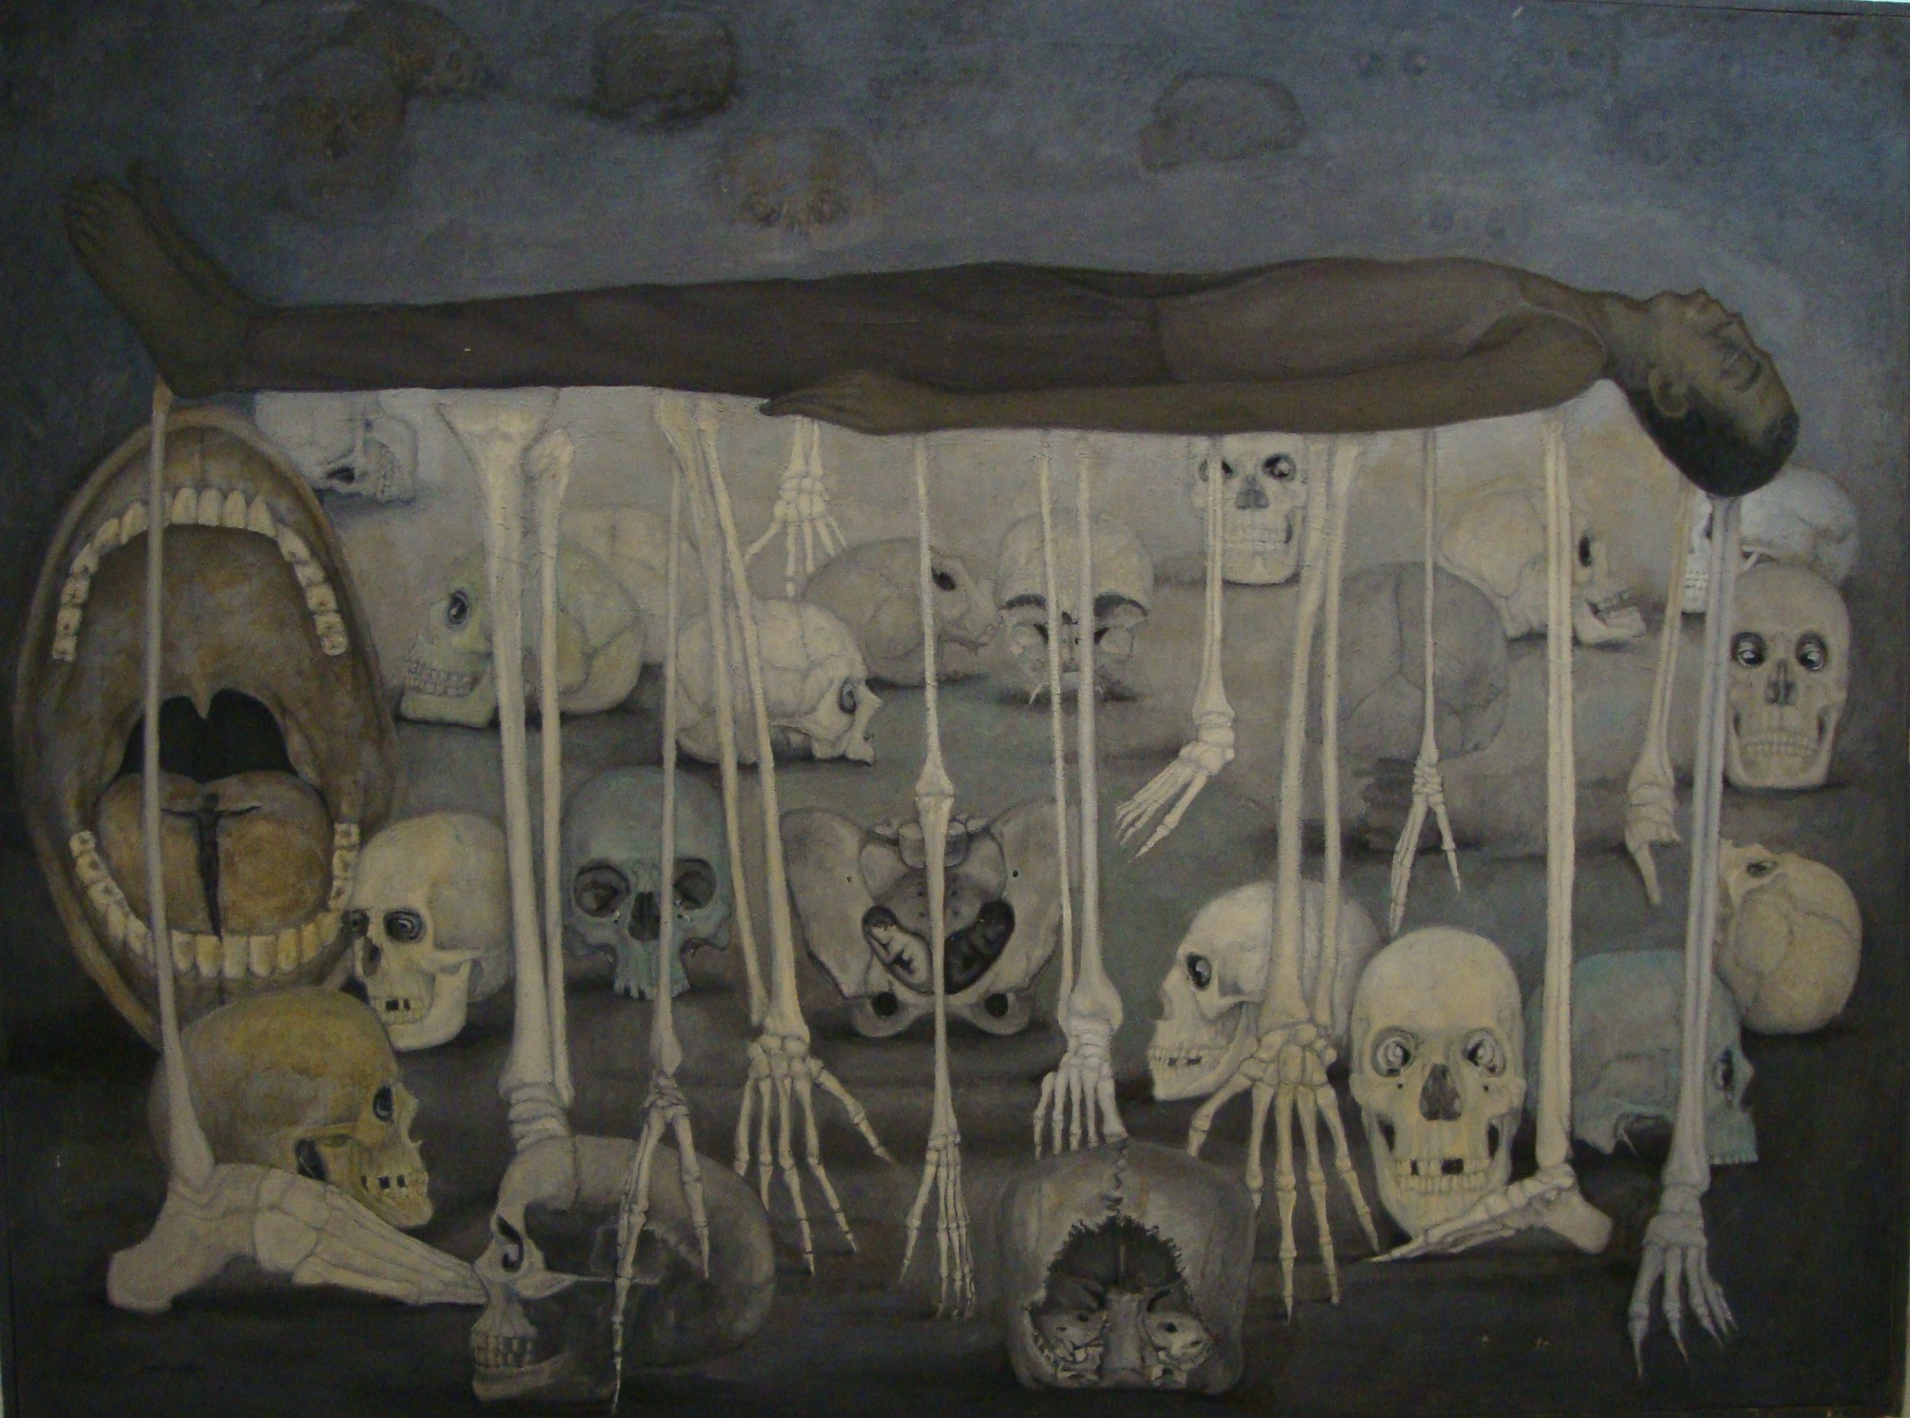

Leila Nseir, *Racism*, 1965, oil on canvas, 106 x 142 cm.

Collection of the Damascus National Museum